Lab - Configure Browser Settings in Windows 7 and Vista
- Introduction
In this lab, you will configure browser settings in Microsoft Internet Explorer.
- Recommended Equipment
- A computer with Windows 7 and Vista installed
- An Internet connection
  - Setting Intenet Explorer as the default browser
    - Choose Start > Search Programs and files in Windows 7 or Choose Start > Start Search in Windows Vista. Type www.cisco.com, and click the link http://www.cisco.com.
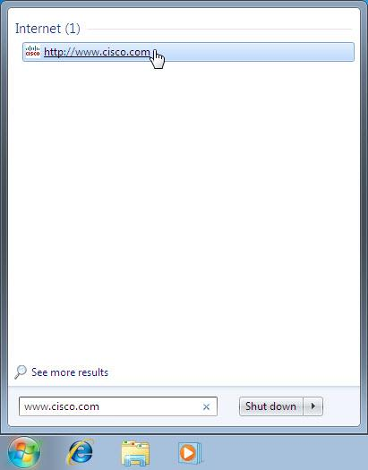
Which browser was used to open the web page?
Internet Explorer.
If your answer is not Internet Explorer, use the following steps to set Internet Explorer as your default browser. Otherwise, go to step b.
      - Choose Start > All Programs > Internet Explorer.
      - Choose Tools > Internet options, and then click the Programs tab.
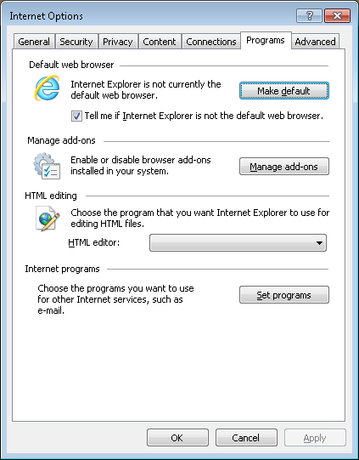
      - Select Tell me if Internet Explorer is not the default web browser and then click OK. Close the browser.
      - Choose Start > All Programs > Internet Explorer.
      - Click Yes to make Internet Explorer the default browser.
    - Click Tools () at the top right hand corner of the window > About Internet Explorer.
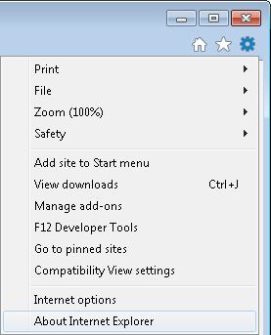
If desired, right-click the title bar and select Menu bar to add the menu to Internet Explorer. Click Help > About Internet Explorer.
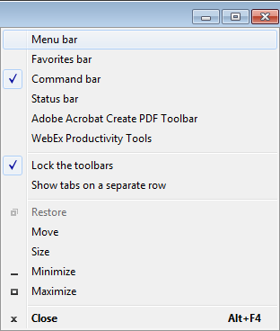
Which version of Internet Explorer is installed on your computer?
Internet Explorer 8.
  - Clear Temporary Internet Files
    - Choose Tools > Internet options. Click the Settings in the Browsing history section in the General tab.
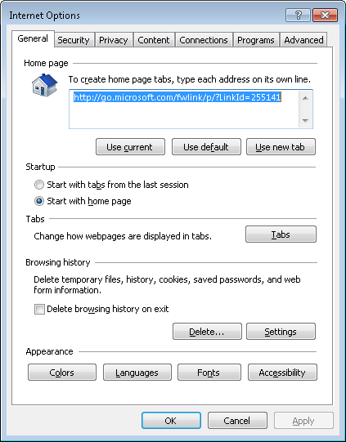
    - In the Website Data Settings window, click View files in the Temporary Internet Files tab to list the temporary Internet files.
Note: In Windows Vista the window is called Temporary Internet Files and History Settings.
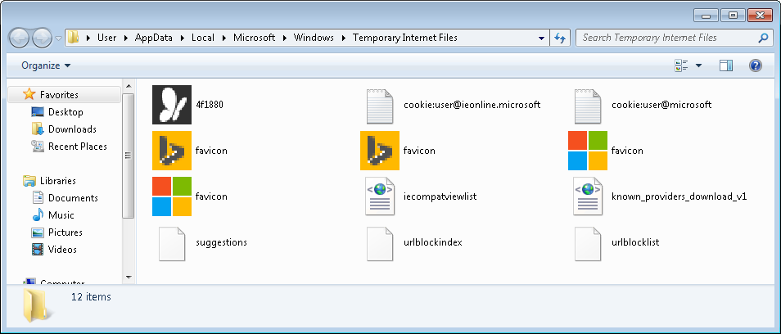
How many temporary Internet files were listed?
2.
    - Close the Temporary Internet Files window.
In the Temporary Internet Files tab or section, which setting is configured for Check for newer versions of stored pages?
Automatically.
In the History tab or section, how many days is History set to store list of visited websites?
20.
    - Close the Website Data Settings or Temporary Internet Files and History Settings window.
    - In the Internet Options window, click Delete… in the General tab to remove Internet browsing history.
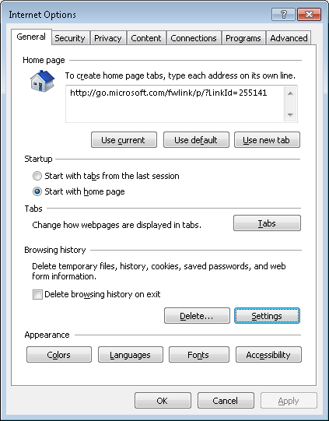
Which options are available in the Delete Browsing History for deleting browsing history?
Preserve Favorites website data, Temporary Internet files, Cookies, History, Form data, Passwords, InPrivate Filtering data.
    - Uncheck all selected options except for Temporary Internet files. Click Delete to remove the temporary files. When completed, Internet Explorer displays the following message:

    - Close all opened windows except for Internet Explorer.
  - Clear Internet Browsing History
    - Open Internet Explorer, if closed, and visit a few web sites using the same tab.
    - Click the down arrow at the right end of the URL Address field to view previously visited sites.
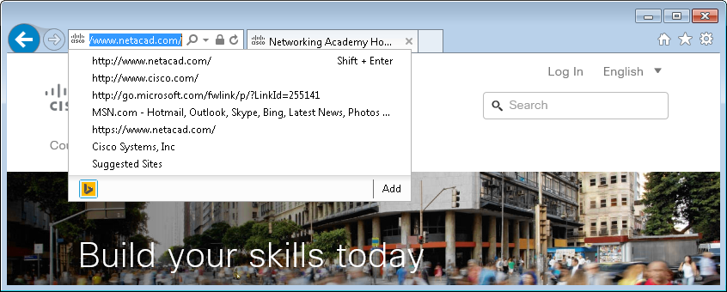
How many sites are listed in the drop-down box? 3.
    - To clear the browser history, choose Tools > Internet options > Delete. Uncheck all selected options except for History. Click Delete.
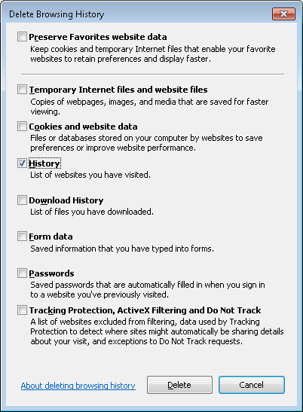
    - Close all open windows except for Internet Explorer.
    - When completed, click the down arrow at the right end of the address field to view previously visited sites.
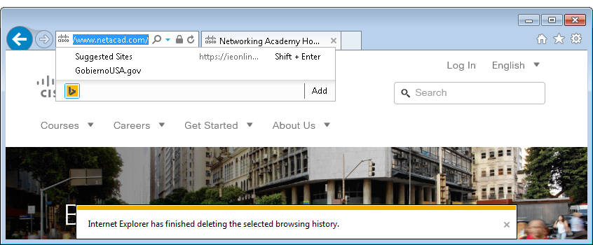
How many sites are now found in the drop-down box for browsing history?
  - Configure the Security Settings
    - Open Internet Explorer as necessary.
    - Choose Tools > Internet Options, and then click the Security tab.
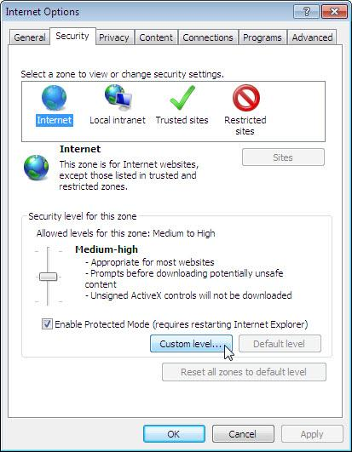
    - Click each of the four zones and describe their security settings.
Internet: For all Internet websites, except those listed in trusted and restricted zones.
Local intranet: For all websites that are found on your intranet.
Trusted sites: Websites that you trust not to damage your computer or your files.
Restricted sites: Websites that might damage your computer or files.
    - Click Custom level…. In this window, you can select the options in the list that you wish to change for a zone. Click Cancel to close this window.
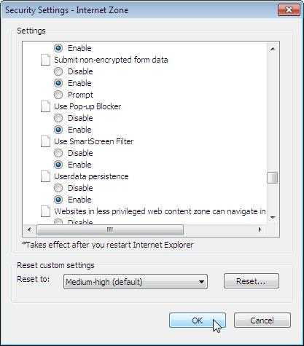
  - Configure Privacy Settings
    - Open Internet Explorer if necessary. Click Tools > Internet options and select the Privacy tab. Click Advanced to open the Advanced Privacy Settings window.
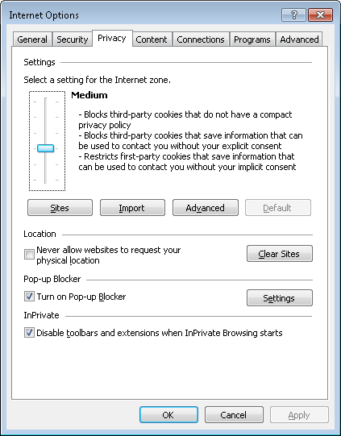
    - In the Advanced Privacy Settings window, click Override automatic cookie handling and change the setting for Third-party Cookies to Prompt.
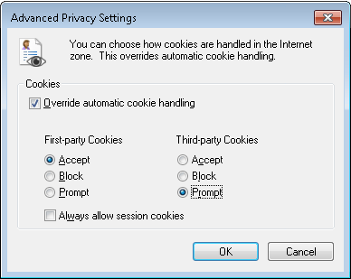
    - Click OK and close all open windows.
- Reflection
Why would you want to clear temporary Internet files or Internet browsing history?
The amount of temporary files and browser history could take up quite a bit of space on the hard drive with data from websites that you may never visit again.

This data could be a privacy concern if the computer is shared because the data can reveal the websites visited in the past.

